DOCUMENTATION

ASSIGNMENT 2

STUDENT NAME: Marin Andreea
GROUP: 30421

CUPRINS

1. Objectives 3
2. Problem analysis, scenarios, use cases 4
3. Design 7
4. Implementation 10
5. Results 15
6. Conclusions 15
7. Bibliography 15

Objectives

- Main objective
Design and implement an application aiming to analyze queuing-based systems by (1) simulating a series of N clients arriving for service, entering Q queues, waiting, being served and finally leaving the queues, and (2) computing the average waiting time, average service time and peak hour.
- Sub-objectives

Analyze the problem and identify requirements | The problem is analyzed and both functional and non-functional requirements are being identified.  (More details: Chapter 2)
Design the simulation application | Divide the problem into three packages: model, businessLogic and view.  (More details: Chapter 3)
Implement the simulation application | Implement method for generating N random clients, strategy methods and run methods associated with the threads.  (More details: Chapter 4)
Test the simulation application | Introduce different values for number of clients, number of queues, min and max arrival time, min and max service time and simulation time and test if clients are assigned to queues such that the waiting time is minimized.  (More details: Chapter 5)

Problem analysis, scenarios, use cases

  - Problem analysis

Improper queue management leads to high waiting times for clients and inefficient usage of resources.
Queue management system implementing efficient queue allocation mechanisms is a solution to the problem. The management of queue-based systems is interested in minimizing the time amount their clients are waiting in queues before they are served. One way to minimize the waiting time is to add more servers, i.e., more queues in the system (each queue is considered as having an associated processor) but this approach increases the costs of the service supplier.

At this point both functional and non-functional requirements can be established:
Functional requirements | Non-functional requirements
The simulation application should allow users to setup the simulation | The simulation application should be intuitive and easy to use by the user
The simulation application should allow users to start the simulation
The simulation application should display the real-time queues evolution
The application should generate randomly a certain number of clients

  - Scenarios

Parameters are being entered in an intuitive, user-friendly graphical user interface.
Customers are generated randomly, each having its own ID, arrival time and service time and the number of clients depends on the input values.
A normal functionality of the program involves setting the desired values the required inputs
The user can set:
- The maximum number of queues available to process customers
- The maximum number of clients
- Minimum and maximum arrival: the delay between customers arriving to receive a service
- Minimum and maximum service time: the number of seconds needed for a client to be processed
- Simulation time
The user can read:
- The average service time
- The “peak hour”, when the most clients were served

Simulation starts when the users presses the “Start simulation” button and ends when current time is greater than the simulation time introduced by the user. It one of the inputs has a value equal to 0 or smaller than 0 the error message “Invalid input data!” will be displayed on the screen.

  - Use cases

A use case is a methodology used in system analysis to identify, clarify and organize system requirements. The use case is made up of a set of possible sequences of interactions between systems and users in a particular environment and related to a particular goal. A complete use case will include one main or basic flow and various alternate flows. The alternate flow, also known as an extending use case, describes normal variations to the basic flow as well as unusual situations.
The use cases are strongly connected with the steps that the user has to do in order to be able to see the result of the chosen operation.
Example for use case:
Use case: setup simulation
Primary Actor: user
Main Success Scenario:
- The user inserts the values for the: number of clients, number of queues, simulation interval, minimum and maximum arrival time, minimum and maximum service time
- The user clicks on the “Start simulation” button
- The application starts the simulation
Alternative Sequence: Invalid values for the setup parameters
- The user inserts invalid values for the application’s setup parameters
- The application displays an error message
- The scenario returns to step 1

Use case diagram

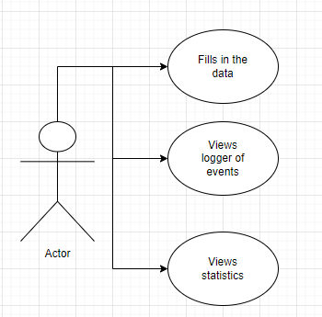

The actor interacts with the application and after filling in the data, he can see the logger of events and the statistics (average waiting time, average service time and peak hour).

3. Design
Conceptual Architecture

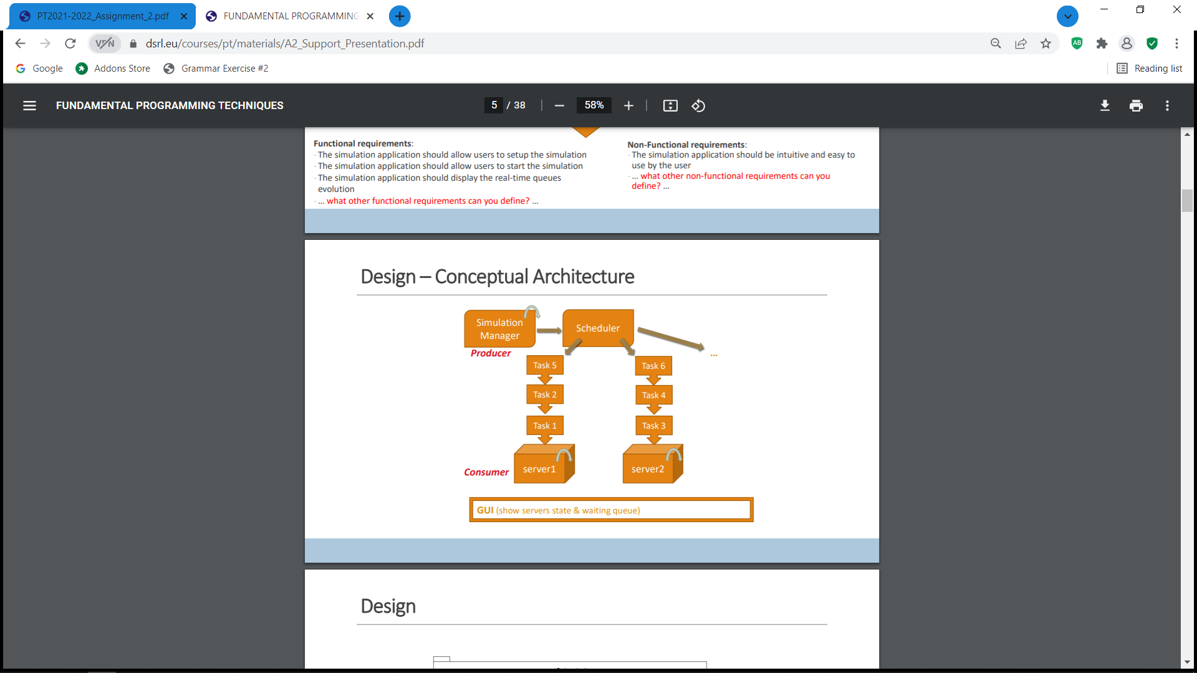

My project contains three packages: model, businessLogic and view.

The first package, model, is the central component of the pattern. It is the application's dynamic data structure, independent of the user interface. It directly manages the data, logic and rules of the application.

The second package, businessLogic, accepts input and converts it to commands for the model or view.

The third package, view, renders presentation of the model in a particular format.

  - UML Diagrams:

- Package diagram

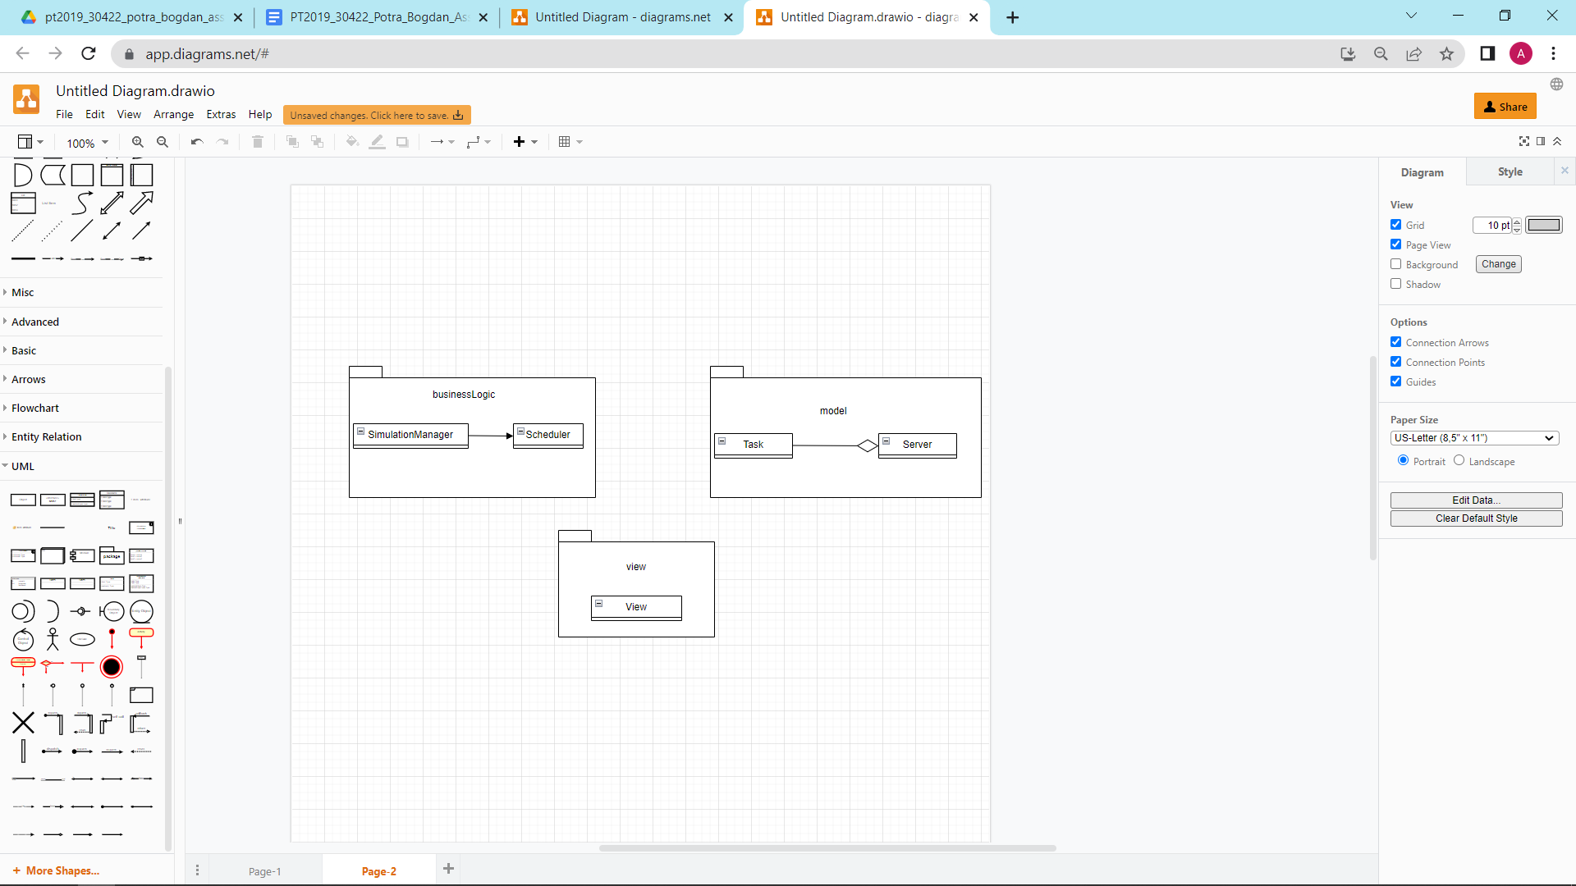

- Class diagram

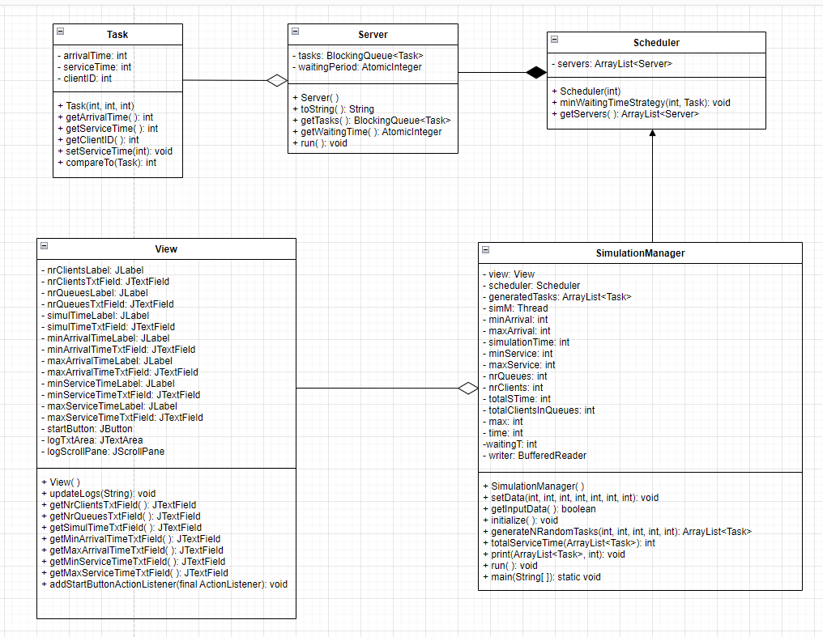

  - Data structures used

For this project I used the primitive data type int, ArrayList and BlockingQueue. I have decided to use ArrayList instead of array because it is more flexible than a plain native array. Working with ArrayLists gave me the possibility of increasing its size dynamically as it has variable length. A blocking queue is a queue that blocks when you try to dequeue from it and the queue is empty, or if you try to enqueue items to it and the queue is already full. A thread trying to dequeue from an empty queue is blocked until some other thread inserts an item into the queue.

  - Interface

I tried to design my interface in a friendly and easy to use way by giving suggestive names to the buttons and labeles.
The user can introduce the desired values for parameters in their corresponding text fields. The given values have to be greater than 0 and the value for minimum arrival time should be less than the value for maximum arrival time and the value for minimum service time should be less than the value for masimum service time.

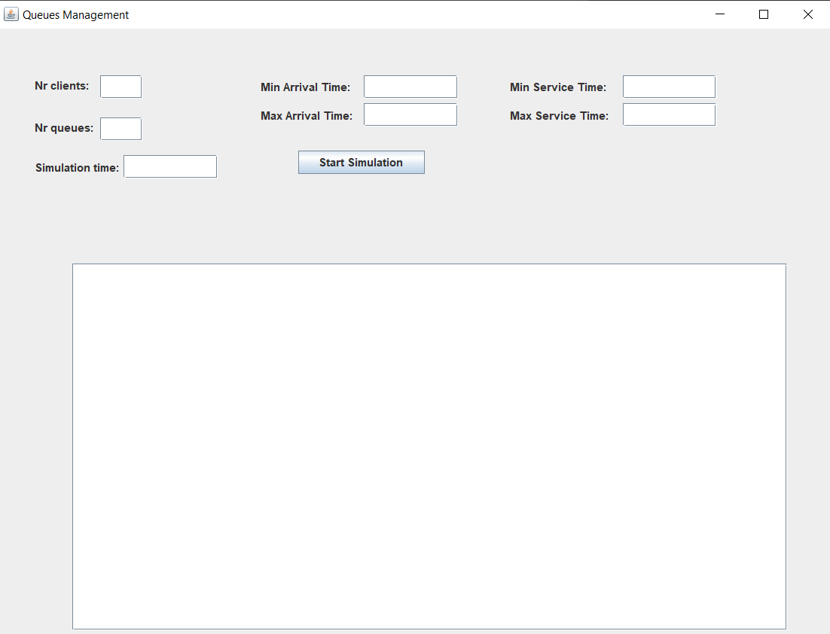

Implementation

A thread in Java is a unit of execution within a process, also called lightweight process. It has shared access to the address space and resources of the process and it mantaines a program counter and a stack. Multithreading is a feature supported by the Java platform.
In order to create threads I used a Runnable object. The Runnable interface defines a single method named run – the method will be implemented by the class implementing the interface and it will include the code that will be executed in the thread.
My project is designed to launch nrQueues threads (where nrQueues is the number of queues), each queue having its own thread, and another thread to hold the simulation time and distribute each client to the queue with the smallest waiting time.
- Package “model”
  - Class Task
This class has three instances: “arrivalTime”, “serviceTime”, and “clientID” of type int

Constructor:
- public Task(int arrivalTime, int serviceTime,int clientID): initializes the client with the arrival time, service time and ID given as parameters

Getters and setters:
- public int getArrivalTime( ): returns the arrival time of the client
- public int getServiceTime( ): returns the service time of the client
- public void setServiceTime(int serviceTime): sets the service time of the client with the given value from parenthesis
- public int getClientId( ): return the ID of the client

Methods:
- public int compareTo(Task o): overrides the compareTo method and is used for sorting the ArrayList of tasks in ascending order of their arrival time

  - Class Server
This is the class for queue. It has two instances: “tasks” of type BlockingQueue and “waitingPeriod” of type AtomicInteger. It implements the Runnable interface.
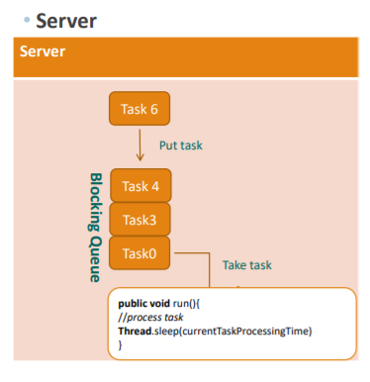
Constructor:
- public Server( ): it initializes the tasks and waitingPeriod

Getters:
- public BlockingQueue<Task> getTasks( ): returns the queue
- public AtomicInteger getWaitingPeriod( ): return the waiting period

Methods:
- public void run( ): the method stops the thread for 1 second, takes the next task from queue, decrements the waitingPeriod and the serviceTime of the task. When the serviceTime of the task equals 0, the task is removed from the queue.

- Package “businessLogic”
  - Class Scheduler
This class has the purpose of sending the task to server according to the established strategy. It contains only one instance: an ArrayList of type Server “servers”.

Constructor:
- public Scheduler(int maxNoServers): for maxNoServers the method creates the server object and adds it to the ArrayList of servers.

Getter:
- public ArrayList<Server> getServers( ): returns the ArrayList of servers

Method:
- public void minWaitingTimeStrategy(int maxNoServers, Task t): this method contains the strategy used for sending the task to server. It finds the server with minimum waiting time and saves its index in the variable “poz”, then adds the task t to that server and updates its waitingPeriod by adding the current waitingPeriod and the serviceTime of the task t.

  - Class “SimulationManager”
The class simulation manager takes the inputs from the graphical user interface, generates randomly the tasks with arrival time and service time and contains the simulation loop. It has as instances a variable view of type View, scheduler of type Scheduler and variables of type for the values taken from the graphical user interface. It implements the Runnable interface.

Constructor:
- public SimulationManager() throws IOException: it initializes the view, the scheduler, the results.txt file for the output and calls the initialize( ) method which start the simulation after the “Start simulation” button is pressed.

Methods:
- public void setData(int arrMin, int arrMax, int serMin, int serMax, int nrQ, int nrC, int simTime): the method sets the values takes from the GUI to the variables declared as instances.
- public boolean getInputData( ): the method takes as strings the values from the GUI and if all conditions for the inputs are respected it calls the setData method, else it displays an error message.
- public void initialize( ): this method adds the startButtonActionListener method from view. After that it calls the getInputData method and if it is true then the scheduler is initialized, the threads, for each server in the scheduler, are created and started, the method for generating randomly the clients is called and the thread for the simulation is started.
- private ArrayList<Task> generateNRandomTasks(int nrTasks, int minArr, int maxArr, int minSer, int maxSer): the method generates randomly nrTasks tasks, adds them to and ArrayList of tasks initialized inside the method, sorts the ArrayList in increasing order of arrival time and returns it.
- public int totalServiceTime(ArrayList<Task> arrayTask): calculates the total service time of the generated clients and returns it.
- public void print(ArrayList<Task> t, int currentTime): prints the output to the graphical user interface and also writes it in the results.txt file.
- public void run( ): it iterates the generatedTasks ArrayList and picks the tasks that have the arrivalTime equal with the currentTime and sens the tasks to queue by calling the minWaitingTimeStrategyMethod from Scheduler. After that it deletes the clients from the list and updates the graphical user interface. It also increments the currentTime variable and waits an interval of 1 second.
- public static void main(String[] args) throws IOException: initializes the SimulationManager in order to start the simulation.

- Package “view”
It contains the class view which has instances for all the labels and text fields from the user interface and also for the Start simulation button. They are initialized, their bounds are set and they are added to the frame. The class also contains getters for all the text fields and a method used for updating the text area in which the output is displayed.

5. Results

The results are displayed both in the graphical user interface and in the results.txt file.

The application was also run on three input data sets, each set having a .txt file with the corresponding results. Test 1.txt contains the result for the first set, Test 2.txt contains the results for the second set and Test 3. Txt contains the result for the third set.

6. Conclusions

This project was a good exercise in remembering the OOP concepts learned in the first semester, but also learning new ones, I found it very useful and challenging at first. Modelling the problem in a right way from the beginning helps you to implement it faster.

I consider that facing problems with your code and trying to make it work by yourself, through the mean of research, has the benefit of learning new concepts and a better use of the known ones. In the end, one of the most important things that I have learnt is working with BlockingQueues and AtomicIntegers as I haven’t worked with them before.

By the means of this project I managed to improve my knowledge about queues processing and how they are implemented on a system, I learned about Threads and about synchronization.

7. Bibliography

- Object-Oriented Programming - Lecture Slides of prof. Marius JOLDOS
- Programming Techniques – Lectures of prof. Cristina Bianca POP
- https://dsrl.eu/courses/pt/materials/PT2021-2022_Assignment_2.pdf
- https://dsrl.eu/courses/pt/materials/A2_Support_Presentation.pdf
- draw.io – for diagrams
- www.stackoverflow.com
- www.wikipedia.org
- draw.io – for diagrams

